To see and access Google Drive on your desktop, you need to download the Google Drive desktop application. Follow these steps to install and access Google Drive on your computer:
- Download Google Drive Desktop App:
  - Go to the Google Drive website: drive.google.com.
  - Click on the "Download" button located at the top right corner.
  - Once the download is complete, open the downloaded file to start the installation.
- Complete the Installation:
  - When you open the installer, follow the instructions to install the Google Drive desktop application on your computer.
  - After installation completes, you'll be prompted to sign in to your Google account.
- Access Google Drive on Your Desktop:
  - Once installation is finished, you'll see the Google Drive icon in the system tray (Windows) or menu bar (macOS).
  - Click on the icon to access your Google Drive files directly. You can also choose to add the Google Drive folder to your Desktop for easier access.
By following these steps, you can easily access your Google Drive files directly from your computer's desktop.

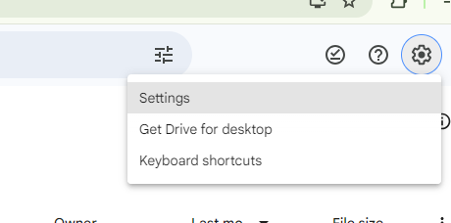

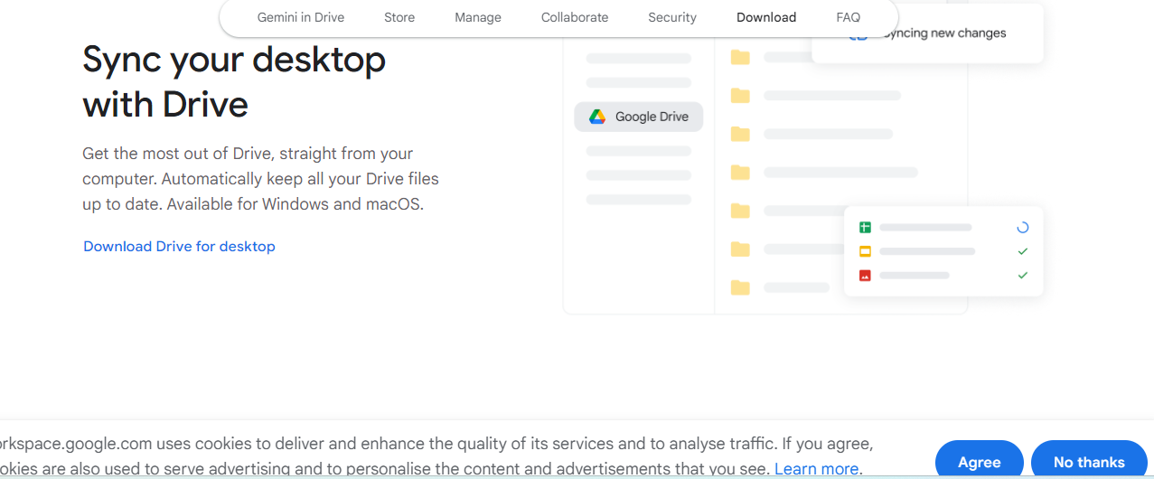

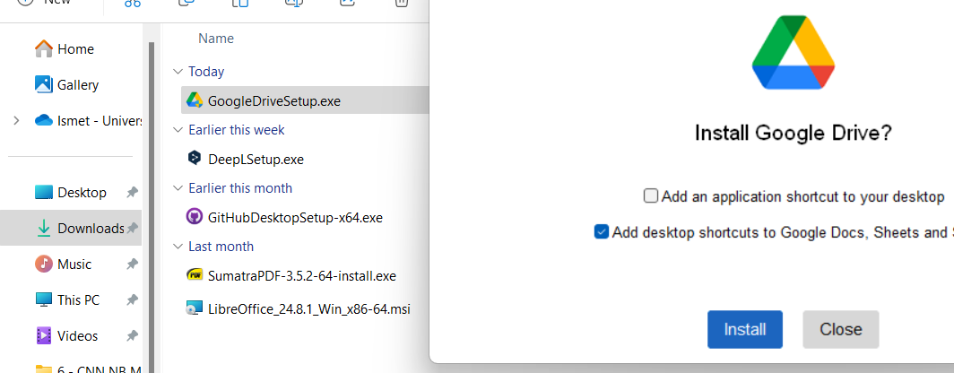

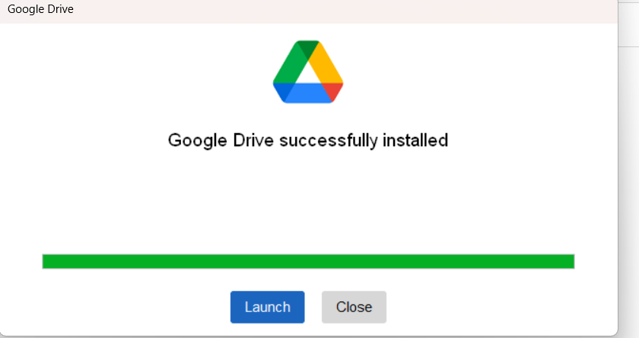

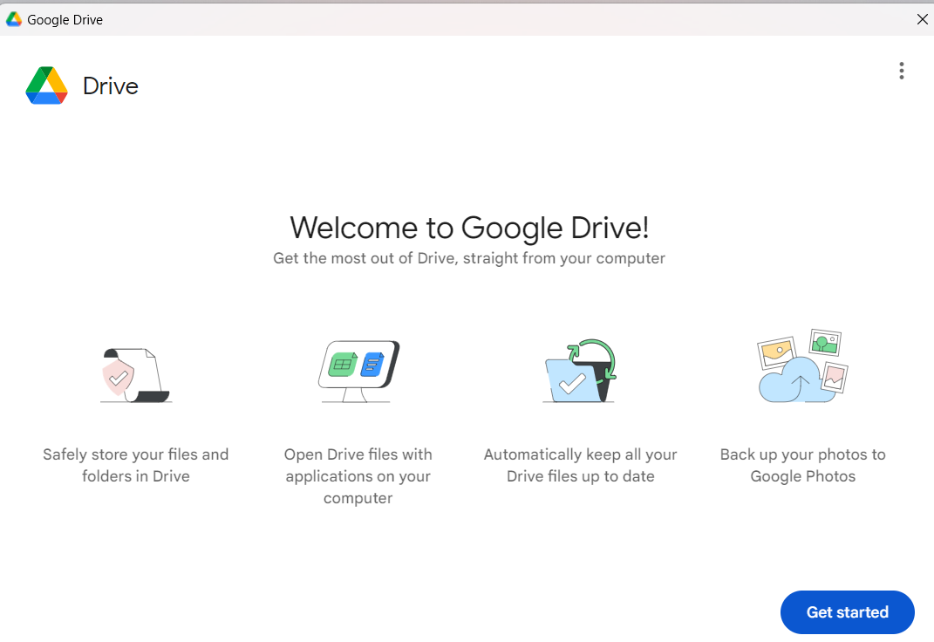

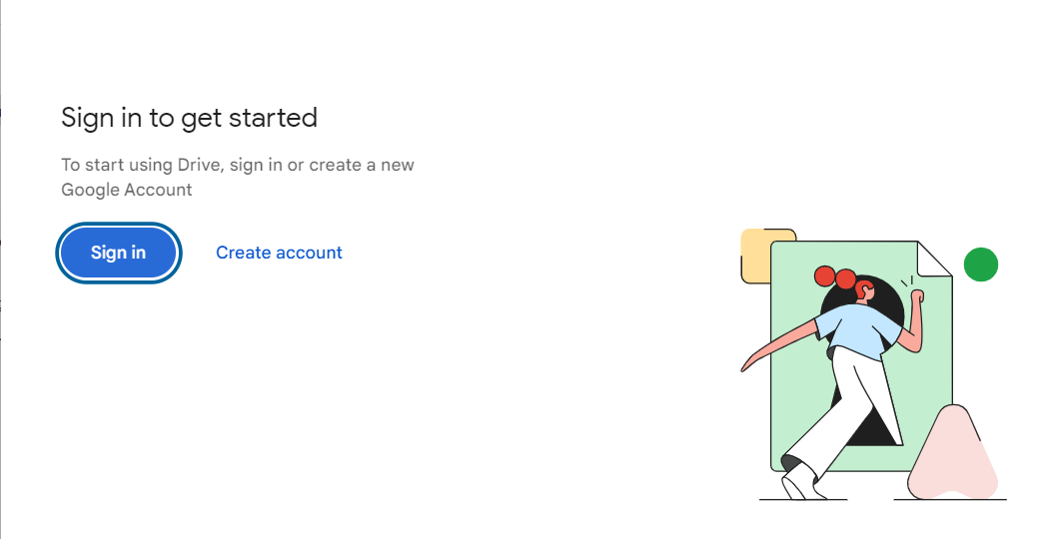

- From now you can access your Google_Drive on your desktop

